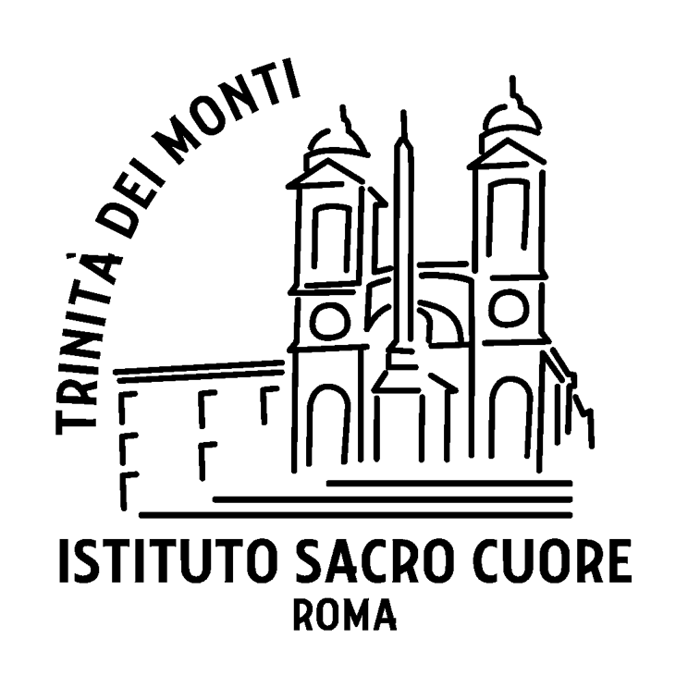 | PHOTO (mandatory portrait)

International Exchange Program of the Sacred Heart Network
STUDENT APPLICATION FORM
EXCHANGE PROGRAM, SHORT TERM STAY (3 or 4 weeks)
This application does not guarantee your automatic acceptance to the program

SCHOOL’S NAME
LAST NAME |  |  |  | Year / Grade
First name |  |  |  | Years in school
Street address |  |  |  | Sisters: name, age
City – (and state) |  |  |  | Brothers: name, age
Zip code |  |  |  | Pets
COUNTRY |  |  |  | Your school’s full name | IST Sacro Cuore  Trinità dei Monti
Date of birth: DD/MM/YYYY |  |  |  | Your school’s full address | Piazza Trinità dei Monti,3 00187 Roma
Phone number |  |  |  | Your exchange coordinator | Eleonora Mei
Religious affiliation |  |  |  | Her/His email | internationalexchangeSCRome@gmail.com
Your email address |  |  |  | Her/His phone
Father’s name |  |  |  | Mother’s name
Father’s occupation |  |  |  | Mother’s occupation
Father’s email |  |  |  | Mother’s email
Father’s cell phone |  |  |  | Mother’s cell phone
Parents’ marital status |  |  |  | If divorced, where do you live?

Name, address and contact information of a relative or family friend
(in case of an emergency if your parents cannot be contacted)
Would it be a problem for you if a member of the host-family smoked? |  | Are you allowed to smoke?
Which sister schools would you like to visit? Name three in order of priority.
Why are you interested in going on exchange? (50 words minimum)
What would you like to gain from an exchange? (50 words minimum)
What personal qualities do you feel would help you while on exchange?
What can you bring to the school you visit? (qualities, etc.) (50 words minimum)
What other experiences have you had living away from home?
Describe your family. Be specific. (200 words)
What responsibilities do you have at home?
What are your hobbies? What do you do after school? What do you do on weekends?
(200 words)
What are your best subjects at school?
On a personal note: please write here what you think is important to consider for your exchange: date restrictions (sports, music, etc.), diet restrictions, allergies, etc.
PARENTS: please write a paragraph that best describes your child. For instance, you could talk about she/he likes and dislikes, what makes her/him uncomfortable, traits of personality that the host-family should about, etc.
PASTE AT LEAST 2 ADDITIONAL PICTURES HERE: family photos, friends, etc.

This application form is your expression of interest in the Sacred Heart international exchange program within the Network of the Sacred Heart schools. You may not apply to the Sacred Heart exchange program if you are currently applying out or considering attending another school in the fall. When considering applications, preference is given to students whose application clearly shows that they are genuinely interested to learn about the other school, about the other country, and about the other culture. The applicant needs to show her ability to fit in with the life of her host family and be willing to help with daily chores. She is asked to comply with the school’s routines and regulations and she must attend the classes offered at the year level in which she is enrolling. She may, under no circumstances, cut class or distract other students from their studies.

If the applicant is deemed by the Exchange Committee to be a suitable candidate for an exchange program, the timing of the requested placement is considered, taking into accounts events on the school’s academic calendar and the program that will be missed at your school. Once approved by the Head of School and the Exchange Coordinator, you will be contacted for further questions.

Date :

This application form must be returned fully completed by email to your exchange coordinator.
An electronic version of this application form must be returned fully completed to internationalexchangeSCRome@gmail.com

Do not forget to include your photo.

Eleonora Mei Ph.D.
Exchange Coordinator
Istituto Sacro Cuore
Piazza Trinità dei Monti 3
00187 Roma

